**Moudie Alhousainan**

**Lab 6 – MAC/ARP**

IT 520-A – Enterprise Infrastructure & Networks

Due Date: 10/29/18 (Handed in at the beginning of class)

Questions: 1. What is the MAC address from your computer?

00:E1:8C:C5:A0:C6

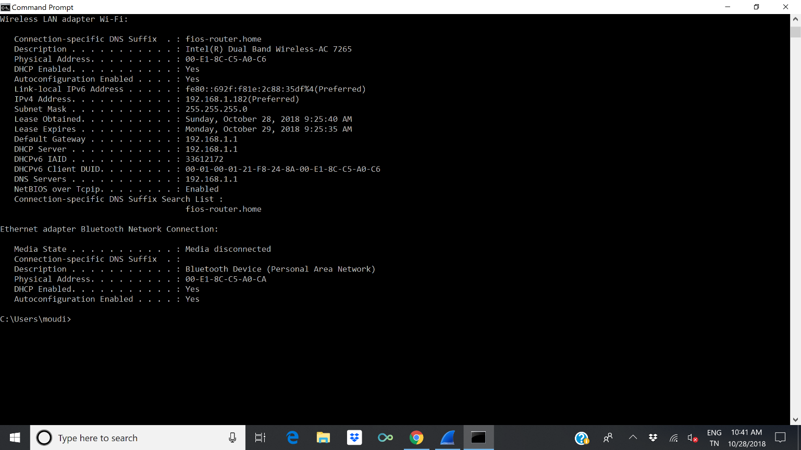

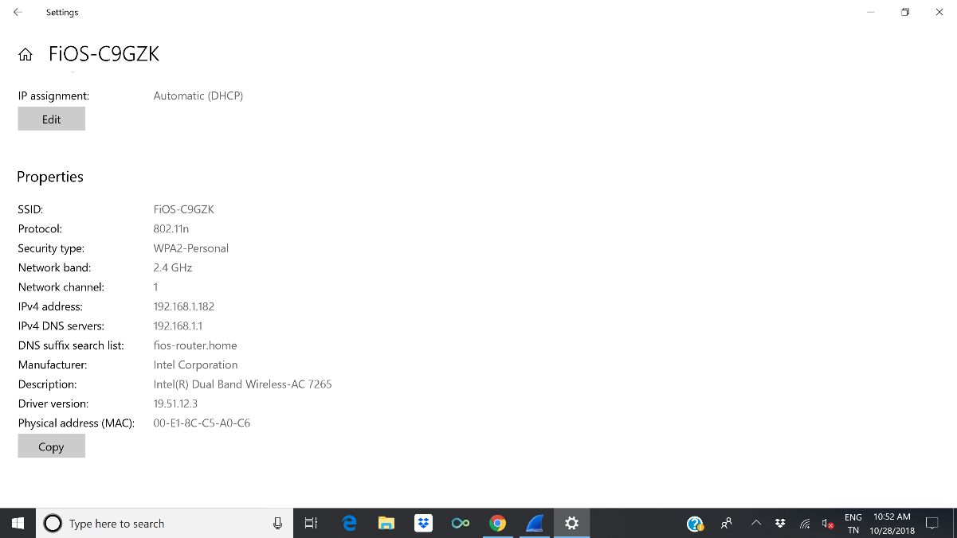

2. What is the destination MAC address?

48:5D:36:A8:F8:D6

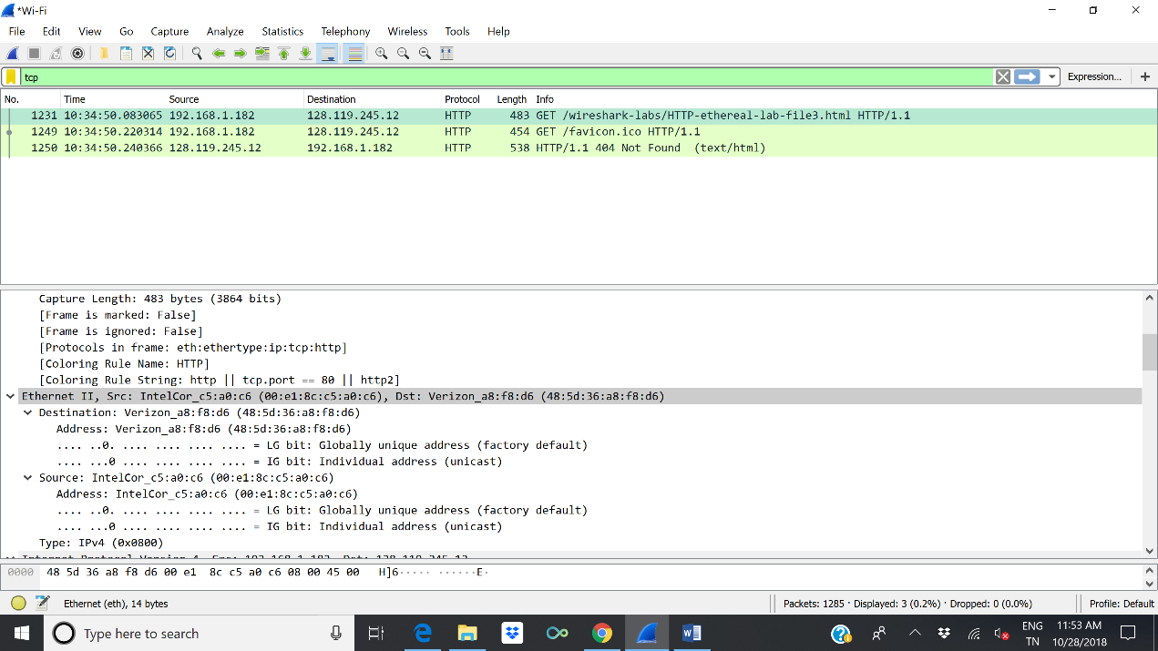

3. What device has the MAC address shown in the destination?

The device that MAC address has shown in the destination is the next directly connected device -first hope-(Verizon router) but not the final destination.

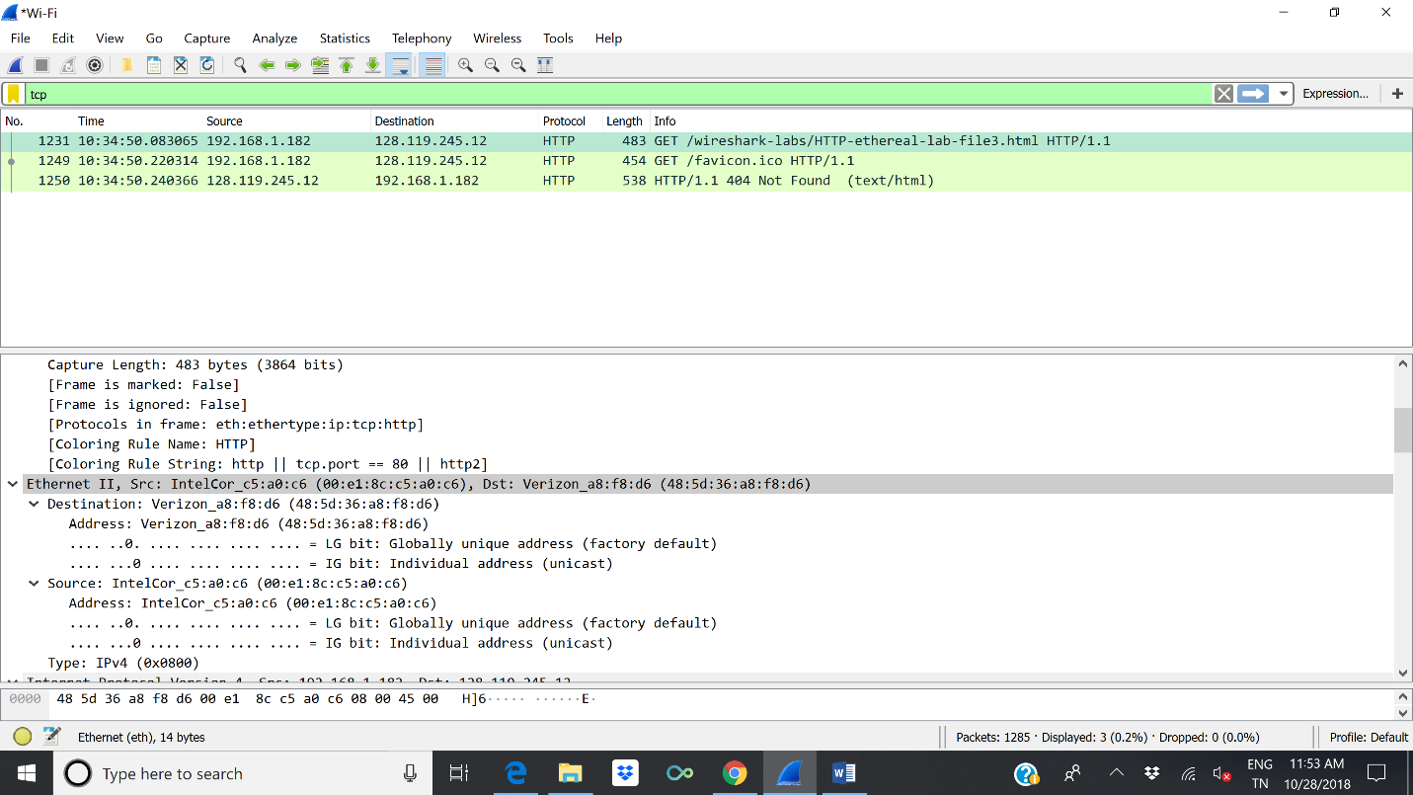

4. Explain the relationship between the destination MAC address and the destination IP address.

MAC address and IP address are completely different, MAC Address is a unique address given to a device by the manufacturer, IP address is used to identify a device over the Internet

When a source host wants to send a datagram to a destination, it does not need to know the target MAC address. Only needs to know the target IP address. only the last router in the chain needs to know the MAC address of the target device. So the datagram contains the target IP address and only the MAC address of the next hope’s device(router).

The router obtains the destination MAC address from ARP. ARP maps IP address to MAC address using ARP table.

5. Using the terminal (cmd in Windows, Terminal in mac), run a command to display your full ARP list table. (Find out what the command is, and print a full screen shot of your result.)

